**Analyzing Effects of Crop, Slope, and Tillage on Soil Loss using WEPP and Excel**

ABE 4803

4/26/22

**Introduction:**

As climate conditions across the globe continue to shift and cause increasingly unpredictable weather patterns with more extreme storm events, soil loss is continuing to be an important issue that environmental engineers must be prepared to address. The conditions that affect soil loss, including intensity and frequency storm events, soil composition, elevation shifts, and agricultural practices are all important metrics that engineers must understand to develop solutions to the problems erosion causes (1). Without proper attention, soil loss can lead to decreases in soil fertility, increased flooding, and increased risk of biological contamination of waterways (2). These are issues that cannot be left unattended. To support the development of proper preventative measures, modeling programs have assisted biological and environmental engineers with quantifying and understanding the multitude of factors that influence and can help predict large scale soil loss. Specifically, the WEPP model was developed to simulate many of the conditions integral to runoff, soil loss, and sediment transport (3). While this model was briefly introduced during this course, further development of modeling skills is necessary to reap the maximum benefits from the WEPP model. The formation of and execution of formal projects provide the perfect opportunity for this development. Therefore, this project was conducted to gain a deeper understanding of the conditions that effect soil loss and potential methods of reducing its harmful impacts.

**Objectives:**

* Develop a greater understanding of the influence that crops, tillage, and slope profile have on soil loss and sediment yield.
* Expand knowledge of proper utilization of modelling software to simulate various scenarios for analysis.
* Accurately analyze and effectively present collected data.

**Materials and Methods:**

Throughout this project, the WEPP model was used for the purpose of simulating scenarios and collecting data for analysis, and Excel was used for the purpose of visually representing and analyzing collected data. During all data collection, climactic conditions in the WEPP were set to State College, MS, soil composition was represented by “glynwood” soil, and published research relating to Mississippi’s agricultural practices were references when necessary. For the first stage of data collection and analysis, twelve scenarios were developed to determine the effects of crop choice and tillage practices, with all twelve being developed with a default slope profile and 100 ft slope length. From each of these scenarios, quantitative data was collected on the soil loss and sediment yield. Corn, soybean, and both corn and soybean were chosen to represent crop choice due to their prevalence in Mississippi’s agriculture (4). Each of these crop choices was combined with one of the following tillage practices: no till, fall moldboard plow, fall mulch till, and spring chisel plow. During this process, an assumption was made that tillage would be most reasonable (4), so the no till scenarios represented a control group to compare the effects of tillage on soil loss and sediment yield. After this data was collected and analyzed, the scenario that presented the greatest reasonable reduction in sediment yield was chosen to move to the next stage of data collection, where the effect of slope profile would be analyzed. For this stage, slope length was increased to 1000 ft and the following slope profiles were chosen to each represent a single scenario: default, uniform, s-shaped, convex, and concave. For each of these scenarios, quantitative data was collected on the soil loss and sediment yield. Additionally, data on the changing soil loss over each slope’s length was exported to Excel and converted to English units to analyze how the rate of slope elevation change effected soil loss.

**Results and Discussion:**

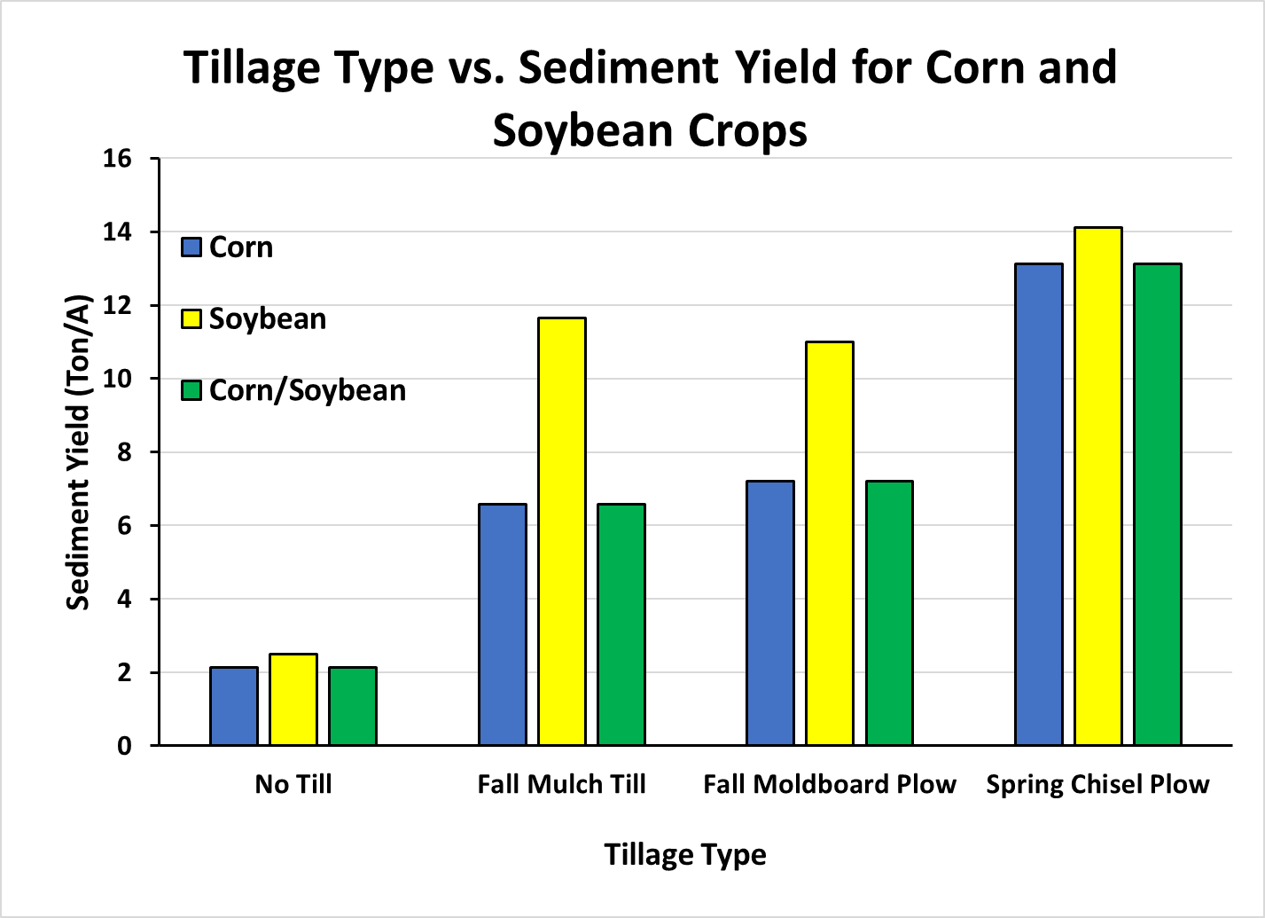Figure 1 illustrates the results gathered during the first stage of analysis. Due to a lack of soil disturbance, each of the crop choices combined with no tilling yielded the lowest overall sediment yield. On the other hand, spring chisel plow yielded the highest sediment yield due to Mississippi’s higher rainfall during the spring season (4). Tilling the soil during these increased rainfall events will drastically increase the amount of erosion. This is due to tillage disrupting soil compaction and making surface layers easier to displace.

Figure 1. Effects of Crop Choice and Tillage Type

Crop choice yielded a more interesting and less anticipated result. While soybean crops alone led to the greatest amount of sediment yield, both corn by itself and corn with soybean crops let to identical amounts of soil loss and sediment yield. Given this result, a combination of soybean and corn crops was chosen to move to the second stage of analysis due to soybean crops being more common in Mississippi’s agricultural practices and diversifying crop cultures being considered a better practice for maintaining soil fertility and increasing crop yields (4). Additionally, the scenarios in the second stage of analysis were ran with fall mulch till since this method provided the optimal results for minimizing erosion. Based on all the data collected from the first stage of analysis, the method of tillage was determined to have a far greater effect on the amount of soil erosion than crop choice.

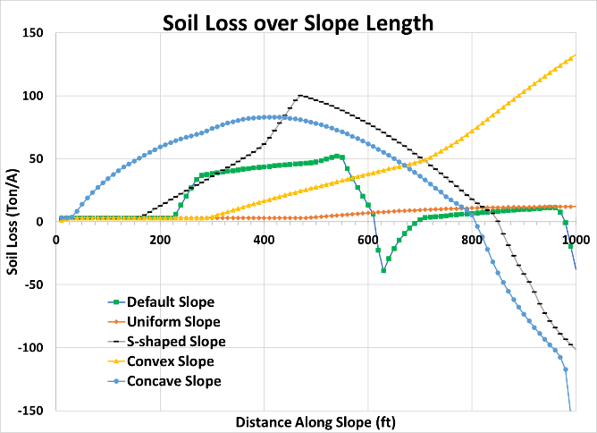The results of the second stage of data collection are illustrated in both Figure 2 and Figure 3.The effect of slope on soil loss and sediment yield was far greater than anticipated. Additionally, a separation between the soil loss and sediment yield was seen where the results from the first stage of analysis were all identical. The increase in slope length was likely a significant factor in this occurrence. The uniform slope profile yielded the greatest reduction in overall soil erosion. This was likely due to a consistent change in elevation along the slope. The concave slope profile resulted in the greatest sediment yield likely due to its drastic elevation decline at the end of the slope. For a more thorough analysis of each slope, Figure 3 illustrates how soil loss changed over the length of each slope. Interestingly, a few of the slop profiles yielded a negative soil loss during a portion of the slope. This is likely due to a nearly constant elevation leading to soil deposition instead of soil displacement. Based on both stages of data collection, the overall best scenario that was developed and analyzed consisted of both corn and soybean for crops, a uniform slope profile, with fall mulch till. Further analysis of scenarios implementing various methods of managing sediment yield, such as sections of the slope being planted with grass or alfalfa with cuttings would be beneficial for refining recommendations.

Figure 3. Soil Loss over Slope Length

Figure 2. Effects of Slope Profile

**References:**

1. Nearing, M., Pruski, F. F. & O’Neal, M. R. Expected climate change impacts on soil erosion rates: A review. *Journal of Soil and Water Conservation* **59**, (2004).

2. Issaka, S. & Ashraf, M. A. Impact of soil erosion and degradation on water quality: a review Sakinatu Issaka & Muhammad Aqeel Ashraf Impact of soil erosion and degradation on water quality: a review. *GeoloGy* **1**, 1–11 (2017).

3. Baffaut, C., Nearing, M. A. & Nicks, A. D. IMPACT OF CLIGEN PARAMETERS ON WEPP-PREDICTED AVERAGE ANNUAL SOIL LOSS. (1996).

4. Watson, V. H. & Lee, J. C. Mississippi Agricultural & Forestry Experiment Station (MAFES) B1143 Current Agricultural Practices of the Mississippi Delta. (2005).

5. Flanagan, D. C., Elliot, W. J., Frankenberger, J. R. & Huang, C. WEPP MODEL APPLICATIONS FOR EVALUATIONS OF BEST MANAGEMENT PRACTICES. (2010).